MATEMATIČKI INSTITUT SANU , ODELENJE ZA MEHANIKU
Mathematical Institute SANU, Belgrade, Department for Mechanics
http://www.mi.sanu.ac.rs/colloquiums/mechcoll.htm
http://www.mi.sanu.ac.rs/colloquiums/collsems.htm
Program of Mechanics Colloquium –JANUARY 2011

Sreda (Wednesday), 12 јануар (January) 2011 u 18 sati (18h) Lecture No. 1141
Prof dr Milutin Marjanov, Matemtical Institute SANU Belgrade

THE MOON AND THE TIDES - INDICATORS OF THE REAL EARTH’S SPIN VELOCITY

What is the period of the Earth's rotation around its axis?
As a rule, answer to this question is that that one turn around the axis of the Earth requires, approximately, 24 hours and that this period is cold the mean solar day. Either, more precisely, some four minutes shorter stellar day.
In fact, neither of these days stands for the Earth's full spin period. Earth turns around its axis considerably more slowly. The only frame of reference in which its intrinsic rotation is clearly defined, while its orbital motions are excluded, has to be the one related with the Moon.
The full spin period of our planet is about 50 minutes longer lunar day – the time between one lunar zenith to the next. The term tidal day is also in use in oceanography

Предавања ће се одржавати средом са почетком у 18.00 часова, у сали 301 F на трећем спрату зграде Математичког института САНУ, Кнез Михаилова 36/III, (зграда преко пута главне зграде САНУ).

Позив научницима и истраживачима да пријаве сцоја предавања
Пријава потенцијалног предавача треба да садржи апстракт предавања до једне странице на српско језику ћирилицом и превод на енглески јеѕик, као и ЦВ обима до две странице. Пријаву послати на адресу управника оделења за механику у виду Word DOC на адресу: khedrih@eunet.rs

*********************
Announcement and Invitation

Start of each lecture is at each Wednesday at 18,00 h in room 301 F at Mathematical Institute SANU, street Knez Mihailova 36/III.

All scientists and researchers in area of Mechanics are invited to contribute to the Program of Mechanics Colloquium of Mathematical Institute of Serbian Academy of Sciences and Arts. One page Abstract of proposed Lecture with short CV is necessary to submit in world doc to Head of Department of Mechanics (address: khedrih@eunet.rs), one month before first day in the next moth.
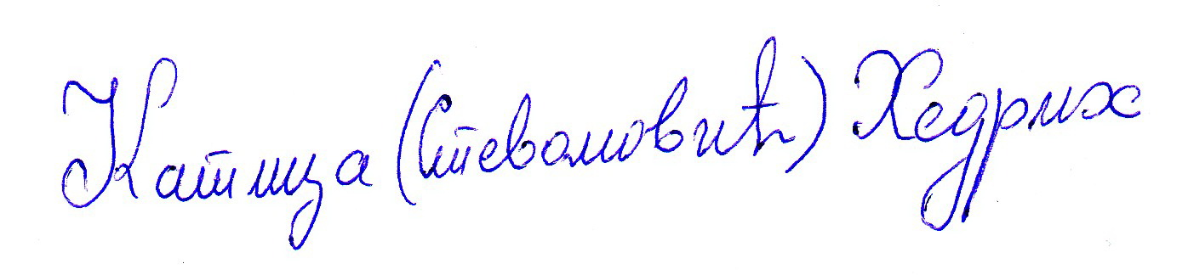
Katica R. (Stevanovic) Hedrih
Head of Department of Mechanics

